Name: ________GovindVuppu_________GR006539____________________

* 1. Build the following network in GNS3 as shown in the figure below.

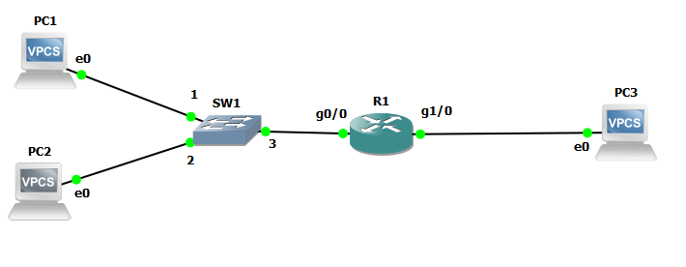

* 2. Using the tables below, configure the router and the interfaces as shown below.

**LabEquipmentIPAddress Information**

|  |  |  |
| --- | --- | --- |
| **Router Name** | **Gi0/0 Address** | **Gi1/0Address** |
| R1 | 192.168.1.1/24 | 192.168.2.1/24 |

|  |  |  |  |
| --- | --- | --- | --- |
| **Host** | **IP Address** | **Subnet Mask** | **Gateway** |
| PC1 | 192.168.1.5 | 255.255.255.0 | 192.168.1.1 |
| PC2 | 192.168.1.6 | 255.255.255.0 | 192.168.1.1 |
| PC3 | 192.168.2.5 | 255.255.255.0 | 192.168.2.1 |

* 3. Verify that all hosts can ping each other. If you can’t ping troubleshoot the problem before continuing with the lab. The ability to ping is a prerequisite to continuing the lab.
* 4. Configure the access list based on the information show below.

|  |  |  |  |
| --- | --- | --- | --- |
| **StopTrafficfromPC2** |  | | |
| **ListNumber** | **PermitorDeny** | **SourceAddress** | **Wildcard Mask** |
| 1 | Deny | 192.168.1.6 | 0.0.0.0 |

On the R1 router, type the following to stop access from PC2.

*R1(config)#access-list 1 deny 192.168.1.6*

* 5. Can PC2 ping PC3? ______________yes___________________ Why? ______as the ip blocked is using deny 192.168.1.6__________
* 6. Apply the access to the interface gi0/0.

*R1(config)#interface Gi0/0*

*R1(config-if)#ip access-group 1 in*

* 7. Can PC2 ping PC3? _________no________________________
* 8. Can PC1 ping PC3? Why? ______ _No because we are doing implicit deny that we can’t see__
* 9. Add the following command to R1:

*R1(config)#access-list 1 permit any*

* 9. Run the following command

*R1#show ip access-lists*

* 10. Take a screenshot of the result and paste it here.

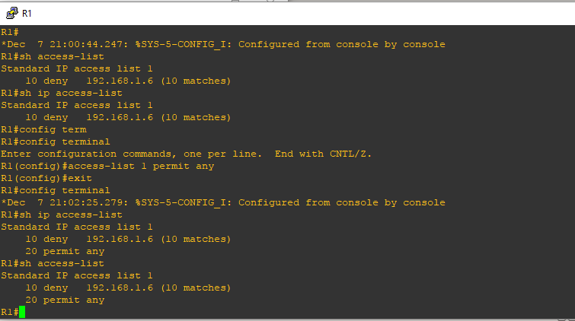

End of Procedure